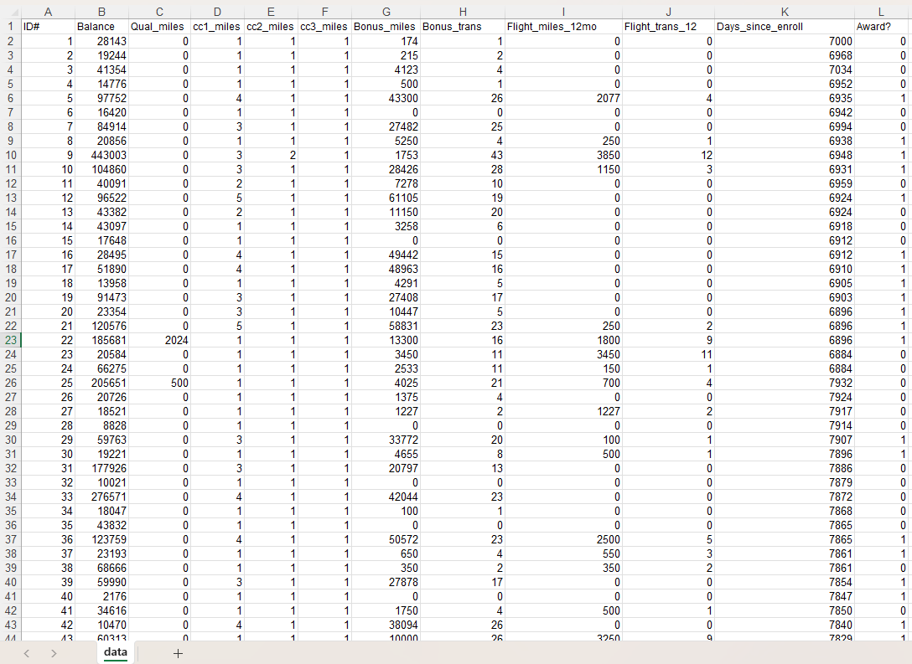
Name of Feature Description Type Relevance w.r.t other Features
1.ID# Unique Identification No Quantitative, Discrete Relevant, Unique customer identification number
2.Balance Balance in Miles Quantitative, Discrete Relevant, Customer’s total saved mile
3.Qual_miles Qualifying miles Quantitative, Discrete Relevant, miles that counts towards special
membership level for airlines’ frequent flyer
program
4.cc1_miles Credit card #1 Quantitative, Discrete partially relevant, miles earned from credit card #1 from airlines
5.cc2_miles Credit card #2 Quantitative, Discrete partially relevant, miles earned from credit card #2 from airlines
6. cc3_miles Credit card #3 Quantitative, Discrete partially relevant, miles earned from credit card #3 from airlines
7.Bonus_miles miles earned Bonus Quantitative, Discrete partially relevant; miles earned from
promotions, bonuses
8.Bonus_trans Bonus transactions Quantitative, Discrete partially relevant, how many times bonus
miles were awarded.
9.Flight_miles_ miles flown Quantitative, Discrete Relevant; miles flown in the last 12 months
12mo
10.Flight_trans_ individual flights Quantitative, Discrete Relevant, Number of individual flights taken in
12 last 12 months
11.Days_since_ Days since joining Quantitative, Discrete partially Relevant, Number of days since the
Enroll customer joined the frequent flyer program.
12.Award? Reward Ticket Quantitative, Binary the customer has used miles to get a free ticket?
(1 = Yes, 0 = No)

